Squirrelvival Project Information

Genre
Hybrid platform and social guessing game

Setting
Southern American swamp, like Florida and Louisiana.
Day and night cycles, using user location data.

Story
Eight squirrels venture out to collect nuts so they can survive the winter. They must avoid the dangers of the swamp and safely make it back to their nest.

Game Mechanics Concept

Technology
- Cloudflare’s Workers
- Cloudflare’s Durable Object
- Wrangler CLI 2
- NextJS
- TailwindCSS
- PixiJS

Tokenomics
Unique NFT game pieces.
Players use TRX to pay a small game entry fee.
Entry fees are pooled for each game.
Winning players split the prize pool.

Game Entry
Players must have a Squirrelvival Squirrel NFT in their wallet to play the game.

Figure 1: Example Squirrelvival Squirrel NFT

NFT
Squirrelvival Squirrel NFTs have dynamic stats. Each NFT can level up and increase stats. NFT levels allow players to enter games with larger prize pools. NFT stats provide a small chance of winning if they make a wrong choice in the game. The unique attributes on each NFT appear on the in-game graphics for each player.

Playing
Eight players appear together on the game stage and must move to one of four muster points before the timer runs out. Each point designates the action a player wishes to take to pass the level. The actions are Dash, Dive, Jump, and Swim.
If a player chooses wrong, they fail the level and become a ghost on screen for the rest of the game. They are no longer able to win the prize pool, but they can use emotes and move on the screen to help or hinder the remaining squirrels. Players may also choose to leave the game at any point after they have failed.
If a player is not on an action muster spot when the timer ends, they fail.
If a player chooses correctly, they win the level and continue playing.
Each game is eight levels long. Players must win all eight levels to win the prize pool. If multiple players win the game, the prize pool is split evenly between all winners.

Game Stage and Levels
Gameplay area:
Vertical scrolling.  The top half of the screen shows the level area. This is where the level hazards appear. The level graphics change for each level as players progress. Aside from the hazards, the final level always shows the final goal, the squirrel’s nest.  The bottom half of the screen shows the stage area. This is where the player’s squirrels appear and move on screen to choose an action. The stage appearance does not change during a game. | 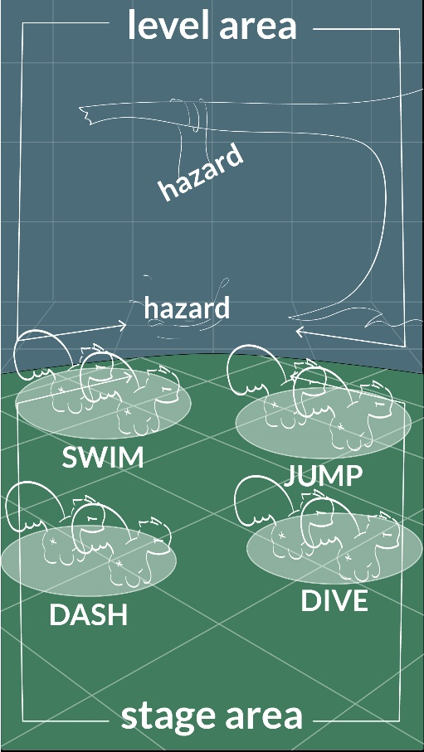  Figure 2 Game screen layout mock-up

Game Controls
Computer browser – WSAD, Arrows, and Click
Mobile and touch capable – Swipe and Tap

Communication
Players communicate in game by using emotes.

Concept Art and Design
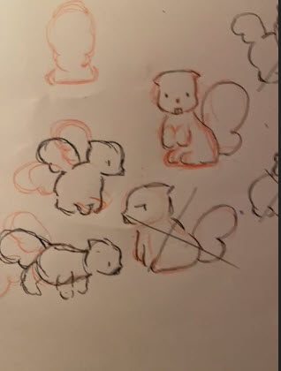 | 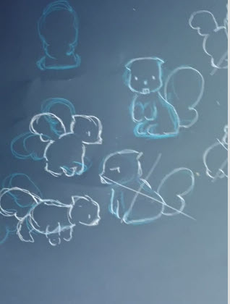
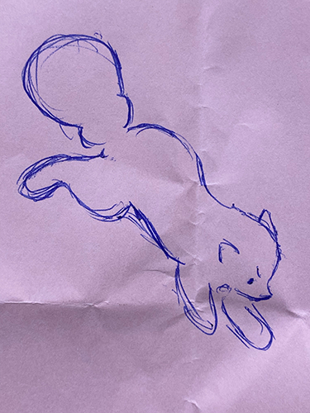 | 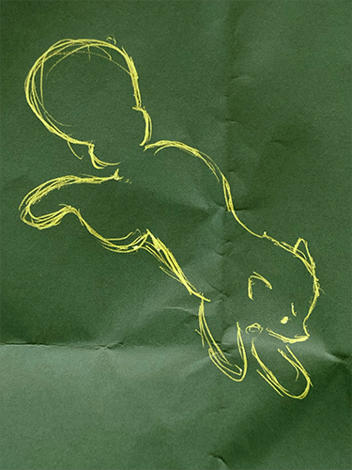
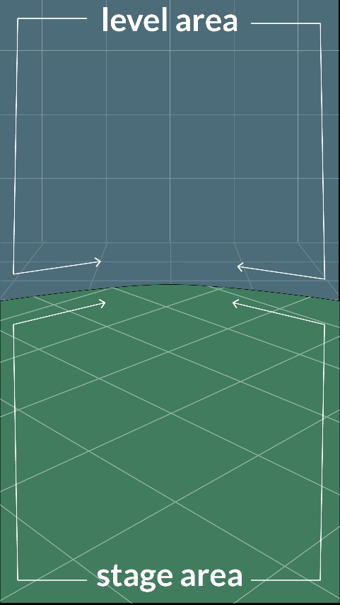 | 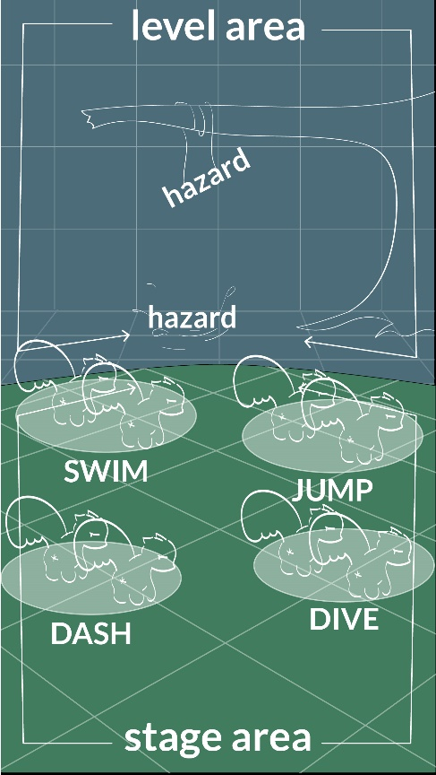
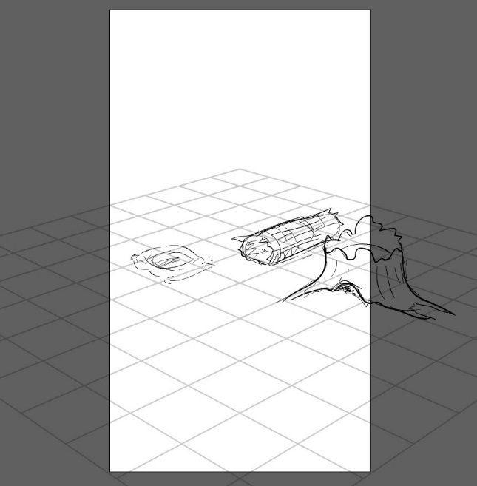

*This is a work in progress and will be updated regularly to reflect changes.

